Jeff Levine - CS 499 Module One Assignment Template

- Self-Introduction: Address all of the following questions to introduce yourself.

  - How long have you been in the Computer Science program?

With SNHU, I have been in the computer science program for roughly the last two and a half years. I also have experience in the workplace as a fullstack developer and have lately been working with LLMs to create a chatbot for my current employer.

  - What have you learned while in the program? List three of the most important concepts or skills you have learned.

- Full-Stack Development (MEAN Stack): Building decoupled web applications using MongoDB, Express.js, Angular, and Node.js with RESTful APIs.

- Algorithms & Performance Optimization: Analyzing time/space complexity and implementing efficient data processing routines.

- Database & Application Security: Implementing JWT (JSON Web Tokens), schema validation, and secure authentication workflows to protect user data.

  - Discuss the specific skills you aim to demonstrate through your enhancements to reach each of the course outcomes.

- Software Engineering and Design: Refactoring Angular components, improving client-server API architecture, and implementing robust error handling across the Express controller layer.

- Algorithms and Data Structures: Optimizing resort/trip filtering algorithms and introducing efficient client-side and server-side data caching mechanisms.

- Databases: Strengthening MongoDB schemas with validation rules, building dynamic aggregation pipelines, and implementing Role-Based Access Control (RBAC) for trip administration.

  - How do the specific skills you will demonstrate align with your career plans related to your degree?

My goal is to pursue a career as a Full-Stack Software Engineer. Enhancing the Travlr application demonstrates end-to-end proficiency in frontend UI components, REST API design, logic optimization, and database security, skills directly aligned with modern enterprise web development roles.

  - How does this contribute to the specialization you are targeting for your career?

Focusing on full-stack web architecture solidifies my ability to bridge client-side user experiences with scalable, secure server-side infrastructure.
- ePortfolio Set Up:

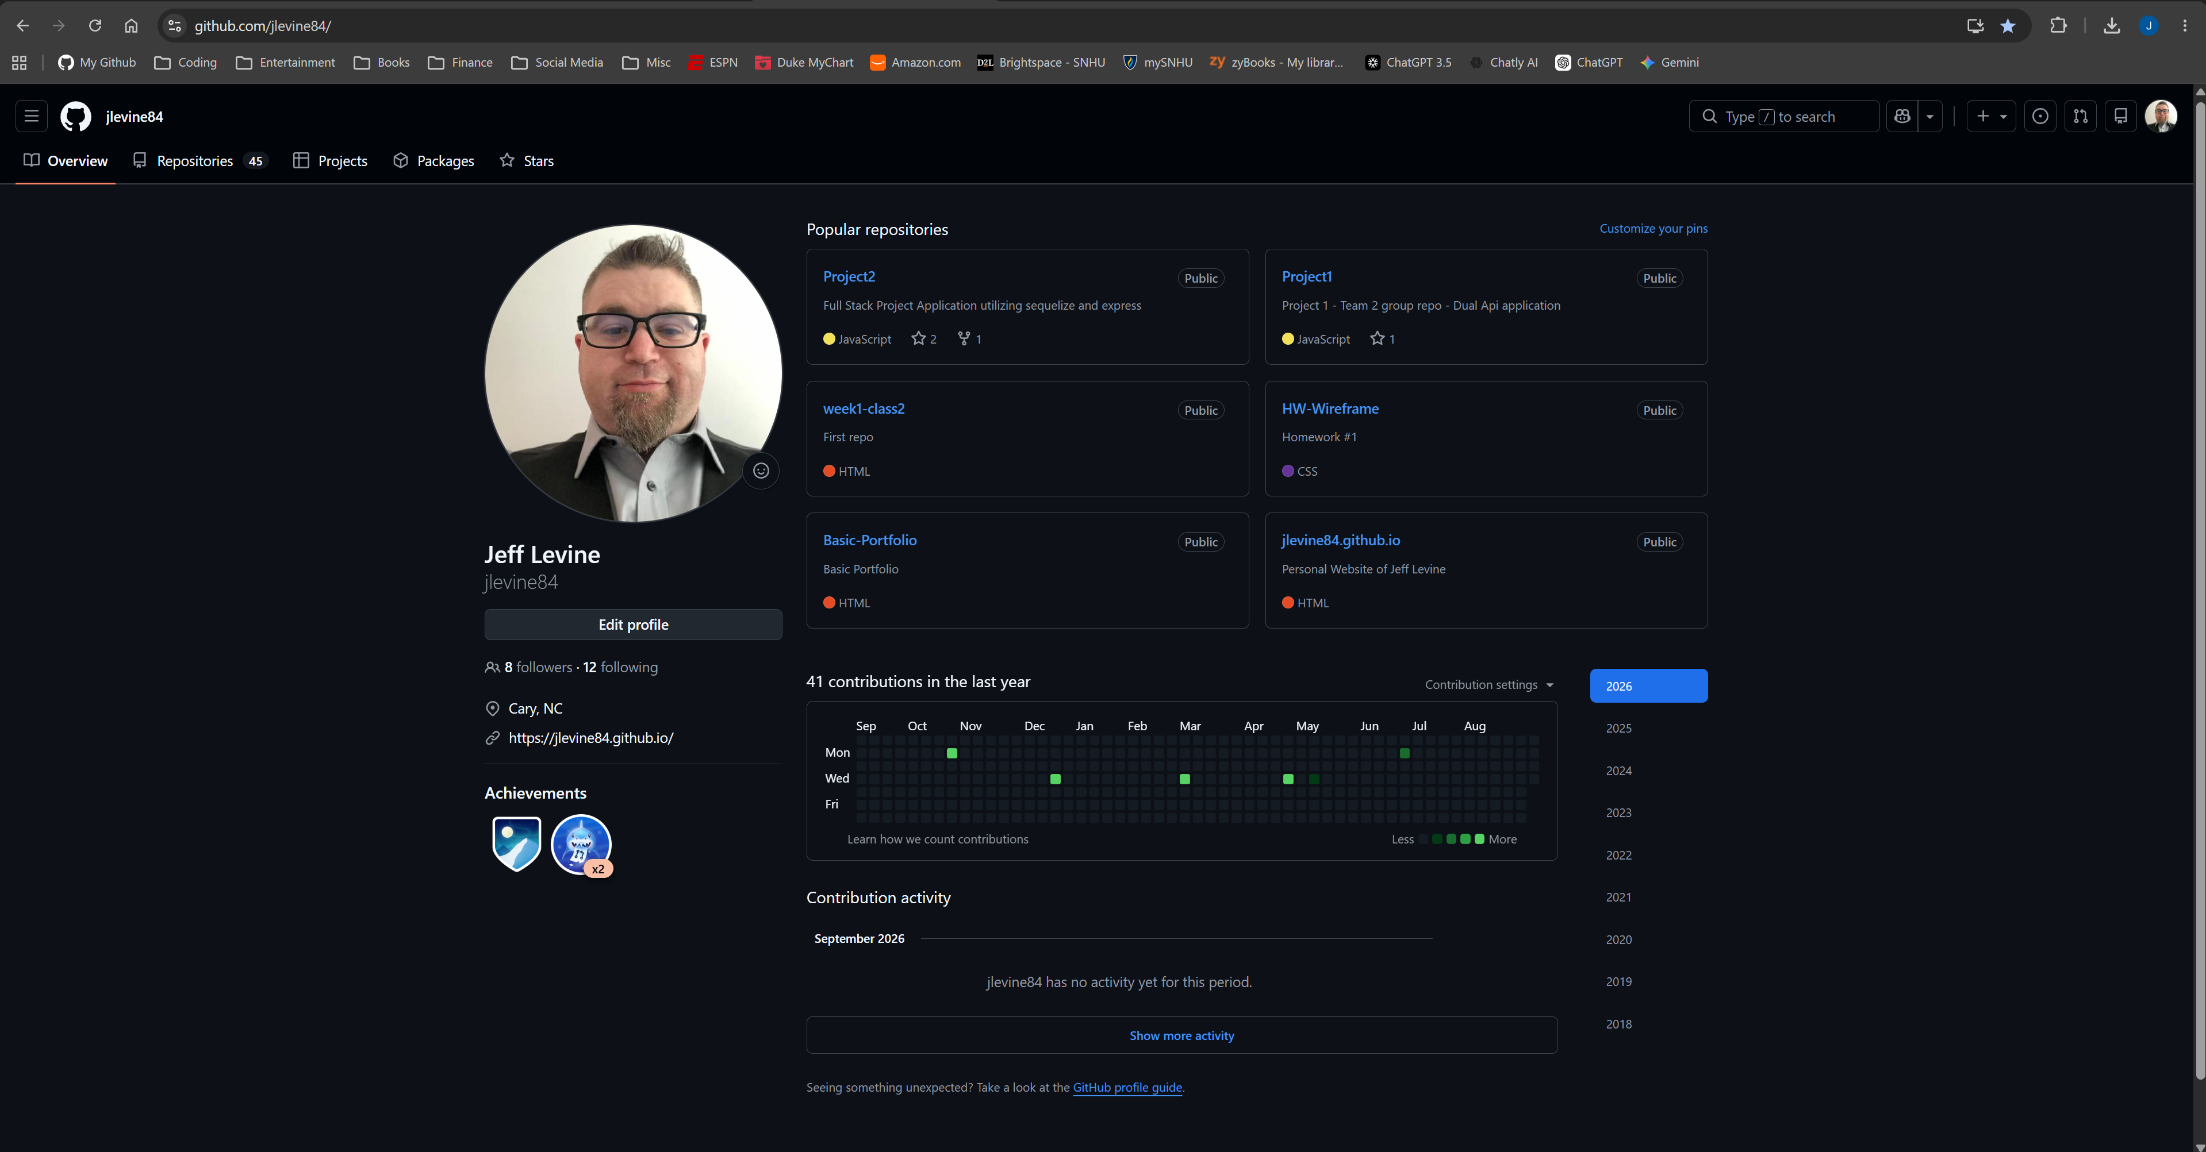
Github profile

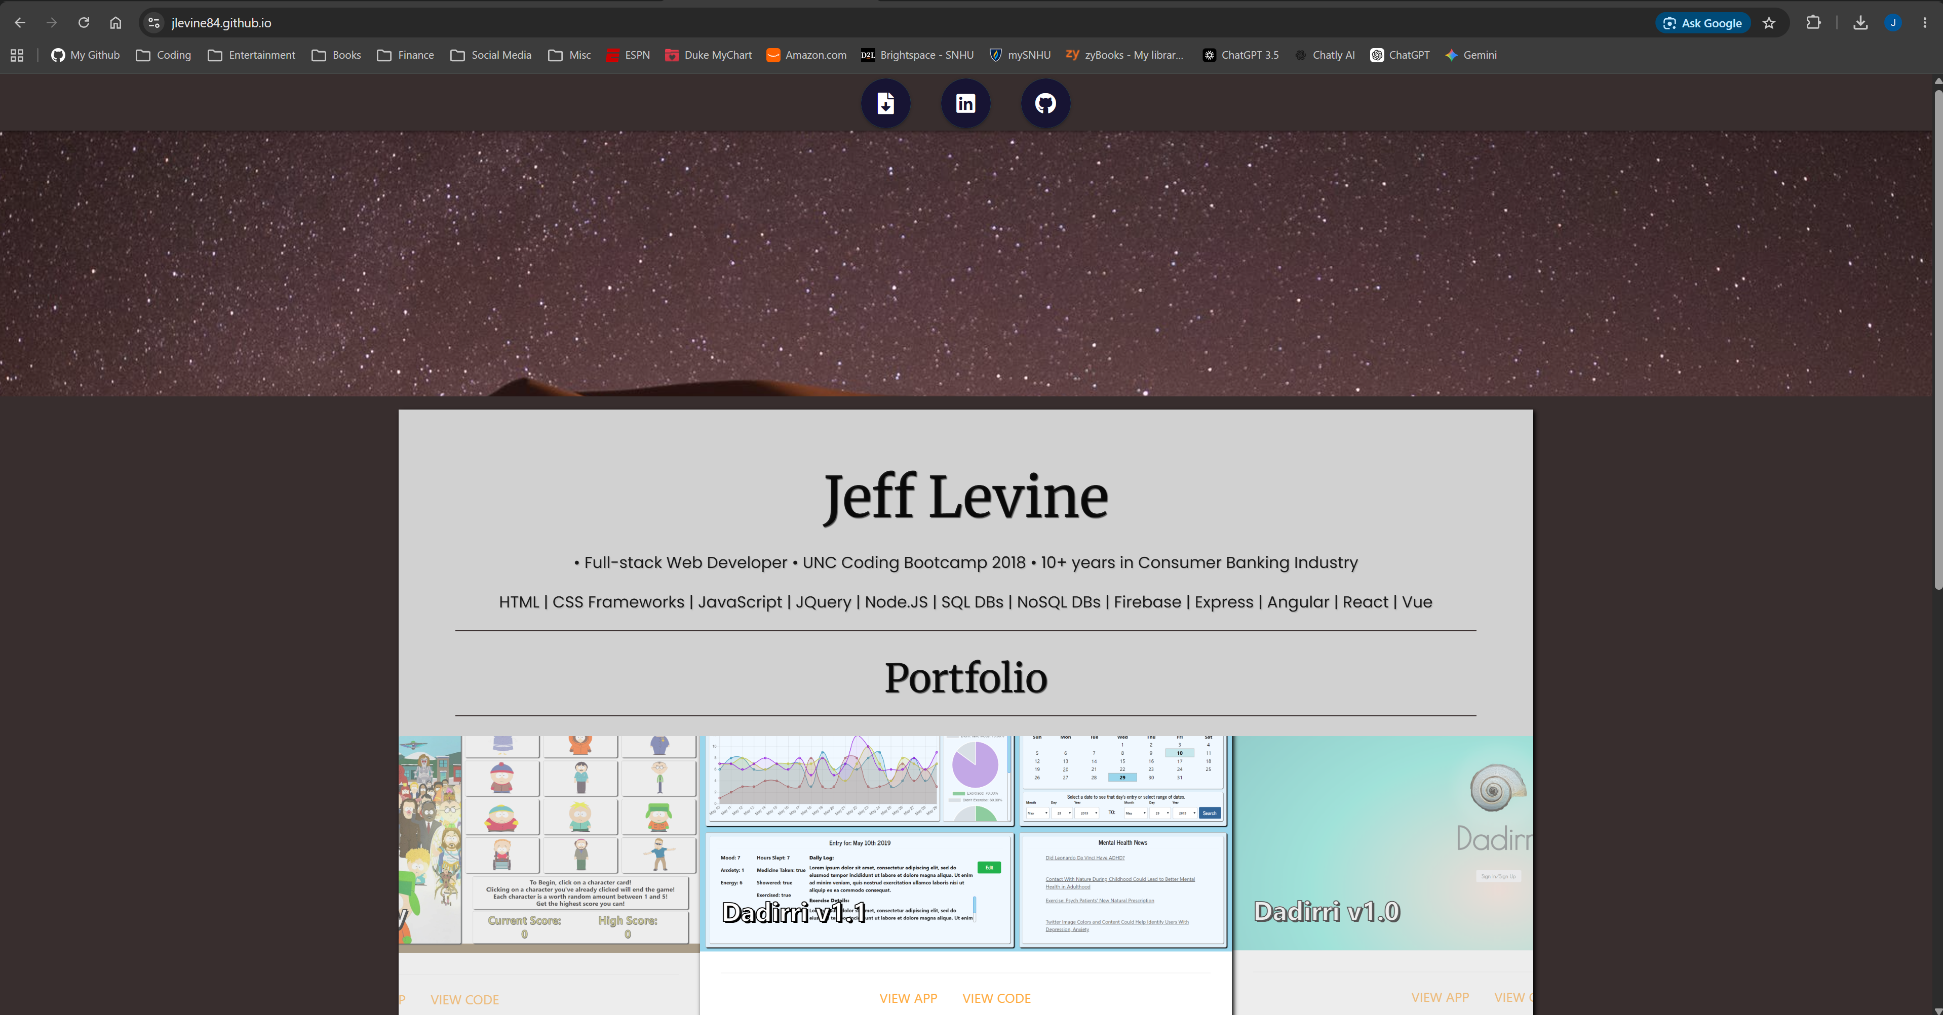
Exisiting portfolio page

- Enhancement Plan:

  - Category One: Software Engineering and Design
    - Select an artifact that is aligned with the software engineering and design category and explain its origin. Submit a file containing the code for the artifact you choose with your enhancement plan.

The artifact selected is the administrative Single-Page Application (SPA) in the Travlr Getaways full-stack application, originally created in CS 465: Full Stack Development. It currently utilizes Angular to provide basic CRUD functionality for travel listings.

    - Describe a practical, well-illustrated plan for enhancement in alignment with the category, including a pseudocode or flowchart that illustrates the planned enhancement.

Enhancement Plan: I will refactor the administrative interface from a basic grid into a interactive dashboard featuring dynamic client-side validation. Using Angular Reactive Forms (FormBuilder), I will implement real-time validation checks for trip creation and edits (such as price bounds, valid date ranges, and code format regex). The UI will dynamically display inline feedback and toggle form actions based on validation states.

CLASS AdminTripFormComponent:
FUNCTION initializeForm():
this.tripForm = FormBuilder.group({
code: ['', [Validators.required, Validators.pattern('^[A-Z]{4}[0-9]{6}$')]],
name: ['', Validators.required],
length: ['', Validators.required],
start: ['', [Validators.required, dateInFutureValidator()]],
perPerson: [0, [Validators.required, Validators.min(0.01)]]
})

FUNCTION onSubmit():
IF this.tripForm.isValid() THEN:
sanitizedData = Sanitize(this.tripForm.value)
TripService.updateTrip(sanitizedData)
ELSE:
this.displayValidationErrors()
END IF

    - Explain how the planned enhancement will demonstrate specific skills and align with course outcomes.

      - Identify and describe the specific skills you will demonstrate that align with the course outcome.

- Refactoring Angular components to utilize Reactive Forms and dynamic state management.
- Implementing client-side input validation and error handling to ensure data integrity before network transmission.
- Enhancing user interface responsiveness and administrative workflow design.

      - Select one or more of the course outcomes below that your enhancement will align with.

- Design, develop, and deliver professional-quality oral, written, and visual communications that are coherent, technically sound, and appropriately adapted to specific audiences and contexts.
- Demonstrate an ability to use well-founded and innovative techniques, skills, and tools in computing practices for the purpose of implementing computer solutions that deliver value and accomplish industry-specific goals.

  - Category Two: Algorithms and Data Structures

- Select an artifact that is aligned with the algorithms and data structures category and explain its origin. Submit a file containing the code for the artifact you choose with your enhancement plan. You may choose work from the courses listed under Category One.

The artifact selected is the RESTful API backend endpoint (/api/trips) within the Travlr Getaways application created in CS 465: Full Stack Development I.

- Describe a practical, well-illustrated plan for enhancement in alignment with the category, including a pseudocode or flowchart that illustrates the planned enhancement.

Enhancement Plan: To complement the refactored admin dashboard, I will replace the flat array query system with an efficient server-side pagination algorithm on the Express/Node.js API. By introducing limit-offset logic with MongoDB sorting, the backend will return fixed data pages (e.g., 10 trips per page) alongside pagination metadata (total pages, current page, total count), reducing time complexity from loading $O\left(n\right)$ total items in browser memory down to $O\left(k\right)$ where $k$ is the page size.

FUNCTION getPaginatedTrips(request, response):
page = parseInt(request.query.page) OR 1
limit = parseInt(request.query.limit) OR 10
skipIndex = (page - 1) * limit

totalRecords = DATABASE.trips.countDocuments()
paginatedResults = DATABASE.trips.find()
.sort({ start: 1 })
.skip(skipIndex)
.limit(limit)

totalPages = Math.ceil(totalRecords / limit)

RETURN response.json({
data: paginatedResults,
currentPage: page,
totalPages: totalPages,
totalRecords: totalRecords
})

- Explain how the planned enhancement will demonstrate specific skills and align with course outcomes.

  - Identify and describe the specific skills you will demonstrate to align with the course outcome.

- Algorithmic complexity evaluation ($Big-O$) to decrease payload sizes and execution memory footprint.
- Designing scalable API data retrieval algorithms for enterprise web systems.
- Efficient execution of pagination logic balancing database query trade-offs.

  - Select one or more of the course outcomes listed under Category One that your enhancement will align with.

- Design and evaluate computing solutions that solve a given problem using algorithmic principles and computer science practices and standards appropriate to its solution while managing the trade-offs involved in design choices.

  - Category Three: Databases

    - Select an artifact that is aligned with the databases category and explain its origin. Submit a file containing the code for the artifact you choose with your enhancement plan. You may choose work from the courses listed under Category One.

The artifact selected is the MongoDB database tier and Mongoose data model layer in the Travlr Getaways application from CS 465: Full Stack Development I.

    - Describe a practical, well-illustrated plan for enhancement in alignment with the category, including a pseudocode or flowchart that illustrates the planned enhancement.

Enhancement Plan: I will expand the database layer to support enterprise audit logs and scalable user relationships. I will create a dedicated AuditLog schema to record every administrative CRUD action (capturing adminId, actionType, targetTripCode, and timestamp). Additionally, I will enforce Mongoose schema validation rules on incoming modifications, create compound indexes on audit and trip queries, and update middleware to guarantee administrative actions are logged automatically upon write execution.

// Audit Log Schema & Middleware Trigger Logic
SCHEMA AuditLogSchema {
adminId: { type: ObjectId, ref: 'User', required: true },
action: { type: String, enum: ['CREATE', 'UPDATE', 'DELETE'], required: true },
tripCode: { type: String, required: true },
timestamp: { type: Date, default: Date.now },
changes: { type: Object }
}

FUNCTION logAdminAction(adminId, action, tripCode, changes):
logEntry = NEW AuditLog({ adminId, action, tripCode, changes })
AWAIT logEntry.save()

// Compound Indexing for Query Performance
CREATE INDEX idx_audit_admin_time ON auditlogs(adminId ASC, timestamp DESC)
    - Explain how the planned enhancement will demonstrate specific skills and align with course outcomes.

      - Identify and describe the specific skills you will demonstrate that align with the course outcome.

- Structuring relational schema connections and audit history in a NoSQL database architecture.
- Applying compound database indexes to optimize history lookup performance.
- Implementing administrative accountability and security monitoring through database middleware triggers.

      - Select one or more of the course outcomes listed under Category One that your enhancement will align with.

- Develop a security mindset that anticipates adversarial exploits in software architecture and designs to expose potential vulnerabilities, mitigate design flaws, and ensure privacy and enhanced security of data and resources.

- ePortfolio Overall Skill Set

  - Accurately describe the skill set to be illustrated by the ePortfolio overall.
    - Skills and outcomes planned to be illustrated in the code review

- Demonstrating critical evaluation of existing full-stack code to identify areas for administrative interface improvement, query optimization, and security logging.
- Technical communication outlining full-stack design trade-offs, reactive form validation, and database audit structures.

    - Skills and outcomes planned to be illustrated in the narratives

- Clear documentation explaining the step-by-step refactoring process across all three categories.
- Alignment of technical enhancements with industry-standard web engineering methodologies and course outcomes.

    - Skills and outcomes planned to be illustrated in the professional self-assessment

- Synthesis of knowledge gained throughout the Computer Science degree program.
- Reflection on developing a security-first engineering mindset, performance optimization capabilities, and professional readiness for full-stack engineering roles.

